**Contract Renewal Process**

MGT 710 Process Innovation and Management

December 10, 2013

Wen Li, Priyam Mishra, Eric Noll, Fatima Porchselvi, Sunny Shah, Priyanka Srivastava

**Table of Contents**

Introduction……………………………………………………………………………………………

Functional Specification………………………………………………………………………………

As-Is Process………………………………………………………………………………………….

Drawbacks………………………………………………………………………………………………

To-Be Process………………………………………………………………………………………….

Reengineering Principles Used…………………………………………………………………………

Process Innovation Change Levers……………………………………………………………………..

Conceptual Data Model…………………………………………………………………………………

Cost Benefit Analysis…………………………………………………………………………………..

Conclusion………………………………………………………………………………………………

**Introduction**

Our business managers need to spend their valuable time on financials and client support rather than going in circles when it comes to the currently lengthy contractor renewal process. In addition to making the business manager run around, other parties involved in the process also have to operate in multiple iterations, which in turn amplifies the affect, this poor system has onto the rest of the company’s resources. By reducing the number of steps and approvals involved in this process, we will be able to let everyone go back to being able to focus on the more important (non-administrative) aspects of their job.

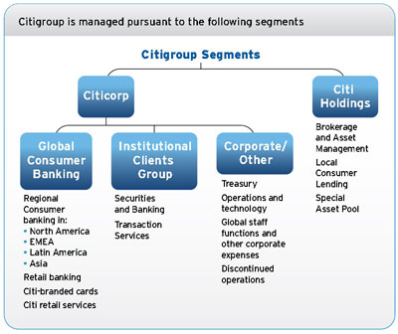Citi is one of the leading global banks out in today’s market. They have over 200 MM customer accounts and do business in over 160 countries. The firm provides an array of financial products and services to consumers, corporations, governments and institutions. These financial products include consumer banking & credit, corporate & investment banking, securities brokerage, transaction services and wealth management to name a few.1

To further explain the company, they currently operate via two primary business segments. The first is Citicorp, this includes their Global Consumer Banking business and the Institutional Clients Group, where it focuses on providing the earlier mentioned financial products and services to its customers. The second business segment is Citi Holdings, where the bank maintains its business and assets, which is not core to its future, including Corporate/Other.1

On a high level, I work for Citi Markets under the Securities & Banking division of Institutional Clients Group. Citi Markets provides specialized products and financial solutions for corporations, governments, and institutional & retail investors.2 Citi Markets is an extremely broad business, we cover products from Equities, Fixed Income, Foreign Exchange, Currencies, all the way to Commodities.3 As previously mentioned, the basic goal of the Citi Markets team is to provide financial products and solutions to our clients. We go about this by splitting the requests up into different asset classes. The three I cover are Equities, Prime Finance & Futures, under these three groups; we have multiple senior managers of technology (SMT) who are responsible for delivering technology solutions to their individual businesses. I provide business office related support to these SMTs.

In my specific position as a business manager, I provide my SMTs with support maintaining their financial planning, resources, client support, human capital, risk & controls, program & financial governance, and internal reporting. Each of those aforementioned categories have subsets of tasks that I cover on a daily basis, but the one we are going to talk about for now is the contractor renewal process.

It’s currently corporate policy in my department that we can only hire a consultant for 6-8 months at a time. With an organization of this size, this means we very often have expiring contractors. When contractors expire, we can either do nothing and let them expire, renew them for another 6-8 months, or even convert them to a full employee.

**Functional Specification**

(Sunny)

Management Model

**As-Is Process**

1. **Contractor renewal process**

This entire process begins when the Central Business Unit (CBU) notifies Business Managers of their upcoming contractor expirations. I’ll take the list of expirations, cut it down to only those which relate to my SMTs, and distribute them to the resource’s managers. When the resource’s manager gets the information, they make the decision whether they want to do nothing and let the resource expire, renew the resource for another 6-8 months, or convert them to an employee.

2a. **Let expire**

To let the resource expire, the resource manager would let me know of their decision, and from there, I will let the CBU know of our decision. The CBU will notify HR that brings us to the end of the process.

**2b. Convert to Employee**

If the manager decides that the consultant is worth being kept around and would like to convert them into a full time employee, then they let me know of their decision. I then check their SMTs budget to see if we have adequate funds to cover the conversion, if so, then I’ll forward the conversion forms to the resource manager. The resource manager would fill the forms out and send them to me so that I can inspect them. If I find any mistakes or require more information from the resource manager then I will have to go back to them. If there are no errors, then I go on to enter the information onto our HR system for conversions, and new hires. HR will then inspect the conversion costs to ensure at a minimum that there is a significant cost savings involved. If not then I will have to go back to the resource manager and review the impact of the increase with their SMT. Once the SMT approves, this will move onto our COO for approval, and back to me. After I get notified of the approval, I advise HR they can send the offer to the contractor onto the next step where they send the offer to the contractor’s agency. The contractor’s agency comes into play and makes sure all the terms are good enough before they inform the contractor of what’s happening. Normally they accept since it means a hefty agency fee for themselves; once they let me know, I pass the message along to HR about the conversion so they can update their systems, and I update my systems for financials and head count reasons.

**2c. Renew the contractor**

If the manager decides that the consultant is worth being kept around and would like to keep things as they are, then they let me know of their decision. I then forward the conversion forms to the resource manager. The resource manager would fill the forms out and send them to me so that I can inspect them. If I find any mistakes or require more information from the resource manager then I will have to go back to them. If there are no errors, then I go on to enter the information onto the CBU’s SharePoint site for renewals. The CBU will follow the same process I did, they will inspect the information I gave them, and if they find any mistakes or require more information, then I will send it back to me, and I will have to go all the way back to the resource manager for more information. If there are no errors, then the CBU will extract all requests on the SharePoint site and forward them to our CIO for approval. The CIO takes one week to process these requests, once completed; the CIO will give the file back to the CBU. The CBU will forward the file out to the individual business units. This is when I get the file back in my hands, I see who was approved, and reach out to the contracting agencies to request extensions. If all is accepted, then they let me know, I pass the message along to my resource managers about the renewal and I update my systems for financials and headcount reasons.

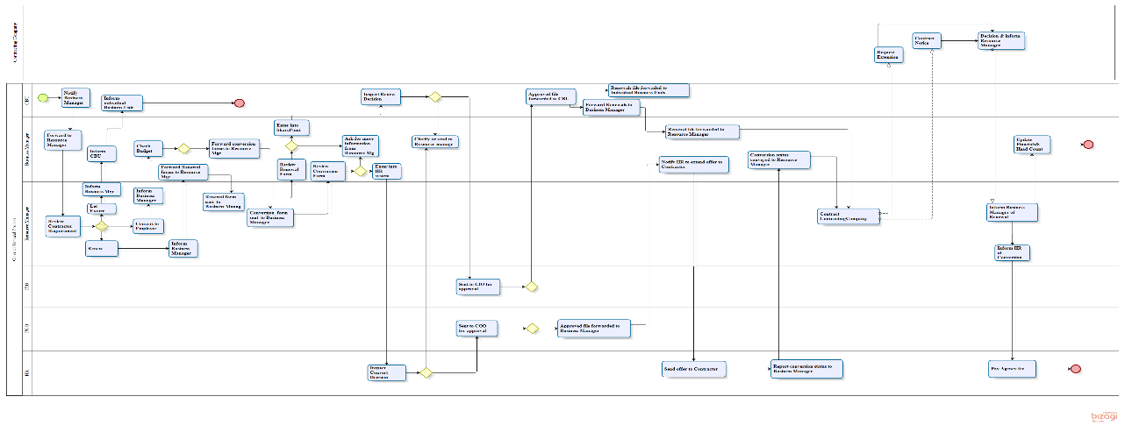

**Drawbacks**

(Fatima)

**To-Be Process**

(Wen)

**To be process organizational goals**

1.To make the whole process more efficient and more automatically compared to the former one.

2.Cut down the human resource. Due to the former one contains so many departments and so many transfers between two departments.

3.There are six review forms process in the as-is process and we want to cut the it to a small number.

4.We should add a new component being the web-based service that automated the processes. The automation part will help us store the form completed in all respect.

**Problems:**

Since the former contractor renewal process has a large numbers of return process from one department to another department. The Business Manager and Recourse Manager do lots of work on transferring the information and checking the information. The Business Manager need to collect the information and transfer the contractor requirement to the resource manager, check the budget if the resource manager approve a new employee, send the renewal forms, conversion forms to the resource manager, review all the forms filled out by the resource manager. After we list the work the Business Manager should do, we find that the work is not in a specific and good order. We should help the business manager delete some actions and make the information transfer become efficient.

**Reengineering work:**

**Cut down the useless actions.**

We need to cut down some transfers between the business manager and resource manager. Because sometimes the things can be done by one department all the way down to another big decision making part. Another thing we should point out is that the business manager seems to be the connection between the CBU and the resource manager, the connection part is not necessary .So we can let the CBU connect directly to the Resource manager. We can use emails to transfer necessary information between the Business manager and the resource manager. And we let the CBU next to the Resource Manager in our map.

Show as this part: 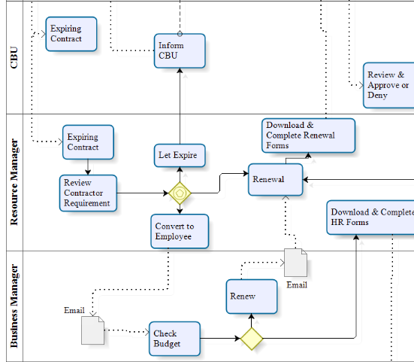

**Automation system:**

The most essential part of our reengineering work is the automation system. In the automation system we add several contractor databases. The database updated automatically through the whole process. Now the business, resource manager and the CBU needn’t send the information from one to the other and repeat the same action. They can get what they want from the database and send what they fix out to the database.

**Fewer departments:**

At the same time we cut the 9 departments to 6 departments. We cancelled the CIO and COO departments and strengthen the ability of HR department. The responsibility of the CIO and COO is deciding whether the company should extend a renewal contract. They are the final decision making departments. Now the CBU takes the responsibility, the CBU review and check the renew form and renew decision saved in the share point and make approval or decline on the contract extension. While the CBU deals with the decision making process, it upload the data into the contract database, so in the following days if the contract agency or any other departments want to check the information, they can get it directly from the database. Another advantage of our contract database is that we can prevent the mistakes happened through the information and data transfer between different departments.

**HR--->VIP.HR**

We also establish the HR system in the VIP HR. In the former process HR should get notification from the business manager then inspect the conversion. After that HR should send their final result back to the business manager. Now the HR can do all the things by themselves. It can absolutely cut down the time and cost on the process.

When it comes to the financial part. Show as the following picture: 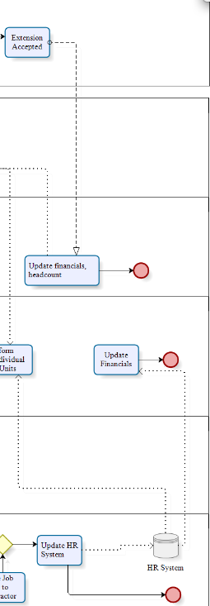

Now CBU is the central department. It deals with financial cost and updates the financial headcount. Business manager needn’t update the financial headcount. After the HR pays the fee to the agency, it will send the data to the resource manager and store the data in its HR system

Although we add the automation system into the process we cut the 41 tasks in the as-is process map to 20 tasks in the to be process map. We accelerate the speed in the contractor renewal process. And we are also capable to guarantee the accuracy of the work.

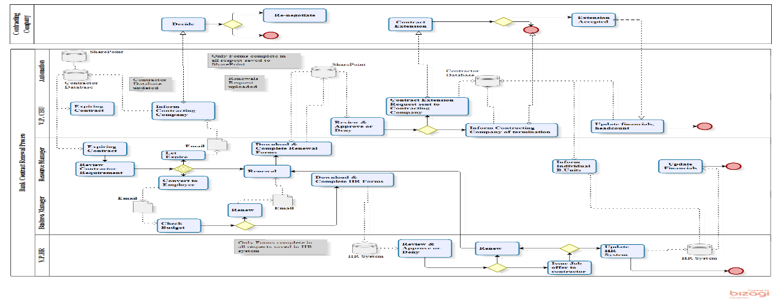

**Reengineering Principles Use**

(Eric)

In all reengineering processes, there are many principles that are used and applied. Many times they may be inherently used without direct intent. In regards to the reengineering of the Citi contract renewal system, there were eight major principles identified in the new “To-Be” process.

The first principle was centralization. Currently, there was no streamline process in place. Contracts were being reviewed as the CBO found that they were near expiration. With the new process, there is a central database for all contracts. This allows for easy access for every group in the company. It also allows for upper management to be more strategic and not have to worry about searching through contracts that are in need of a review.

The next principle was case management. Originally, the process had a very task-oriented division of labor. Resources were used very sequentially. With the new process, case-oriented division of labor can be implemented. Multiple contracts can be reviewed simultaneously. Each contract is specific to an individual group and manger, so the decisions moving forward can be handled by each manager and there is no reason why there cannot be multiple reviews by different managers at the same time.

The reduction of contact points helps to improve communication both internally and externally for the company. Before, there were many different interactions between different groups and managers to review and approve the decisions of the contracts. Now that there is a contractor database with the new process, it creates a single point on contact to review and make decisions on the contracts. A single, universal, interface for all groups involved makes for easier continuity.

The new process also uses the principle of empower workers. In this new review and renewal process, the forms and reviews are all automated. There is no more need for a manager to go to the business manager with the forms for approval of submittal. Each manager has the empowerment to review and submit whatever they want. They just simply process it through SharePoint and the database. This helps to eliminate large role distinction.

This new process also utilizes the complete kit concept. In order to process a contract for renewal or a conversion, it is essential that all the parts are in line. The individual manager has to be in line with HR, finance, the business manager, as well as the contractor themselves. If it were not this way then there would be a huge bottleneck created in the process.

The next applicable principle is informate. This applies directly to the core of the newly created process. Everything being done is in order to automate and digitize everything. All the forms used will become digital and done via email. The notifications and advancements to the next stage are all automated and don not require direct transfer. This improved effectiveness and speed of communication. It also guarantees accuracy for all of the forms.

The removal of disconnects was essential in order to improve this process. By creating logical, fluid, continuous steps in the process, the efficiency and effectiveness improve tremendously. The limiting of reviews saves lots of time as well as cutting down the number of groups involved in the process.

Davenport’s principle of process change and IT are extremely applicable to this new process. The creation of automation is the core of the reengineered process. Creation of a data base does a much better job at not only capturing all the necessary information, but also centralizing it and storing it in one location. It is much easier to track the progress of the process and follow it through to the end.

This reengineered process used many principles that improved the process for the better.

**Process Innovation: Change Levers**

Figure below shows the ‘Change Levers’ or the ‘Process Constituents’ for the to-be process.

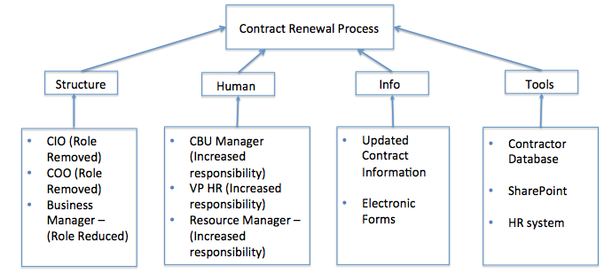

As per the reengineered process, the CIO and COO approvals will not be required anymore. Instead the approval responsibility lies entirely on the CBU, VP HR and the resource manager. Hence they play the most important role in the reengineered process. The latest contract information will be maintained in the database and the electronic forms detailing the contract renewal will be filled up and stored using SharePoint. At the end of the process, the HR system will be accordingly updated to reflect the head count related to the business unit.

**Conceptual Data Model**

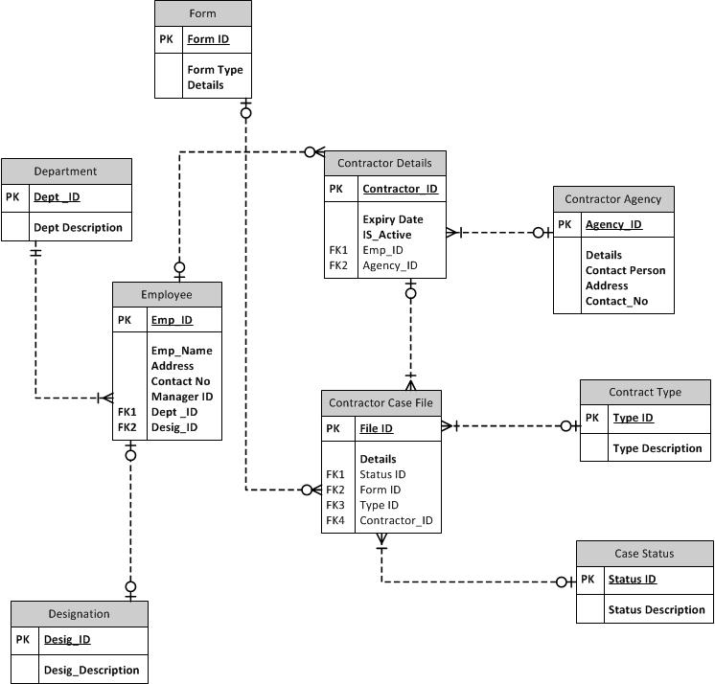

Above figure shows the ER diagram of the reengineered ‘Contract Renewal Process’. Below are the definitions of all the tables in the ER diagram:

|  |  |  |  |  |
| --- | --- | --- | --- | --- |
| TABLE NAME | TABLE DESCRIPTION | COLUMN NAME | DESCRIPTION | ALLOWED VALUES |
| Employee | All Citibank Employee details | Emp_ID | Employee unique identifier | Auto generated value |
|  |  | Manager_ID | Employee’s Manager id | Emp_ID (FK) |
| Contractor Agency | All Contractor agencies’ details | Agency_ID | Contractor Agency unique identifier | Auto generated value |
|  |  | Contact_Person | Point of contact for the agency |  |
| Contractor Details | Contractor Information | Contractor_ID | Contractor unique identifier | Auto generated value |
|  |  | Expiry_Date | Contract expiry date | Date |
|  |  | Is_Active | Contractor Contract status | Yes/No |
|  |  | Emp_ID | Employee ID | Employee table (FK - Emp_ID) |
|  |  | Agency_ID | Contractor Agency ID | Contractor Agency table (FK -Agency_ID) |
| Form | Details of contract renewal request | Form_ID | Form unique identifier | Auto generated value |
| Case Status | Available statuses for the renewal workflow | Status_Description | Status description | In-Progress/  Approved/  Denied |
| Contract Type | Type of process request | Type_Description | Request type description | Contract renewal/Full-time conversion |
| Contractor Case File | Details of all Contract renewal requests | File_ID | Request unique identifier | Auto generated value |
|  |  | Status_ID | Request status | Case Status table (FK - Status_ID) |
|  |  | Type_ID | Type of request | Contract Type table (FK – Type_ID) |
|  |  | Contractor_ID | Contractor ID | Contractor Details table (FK – Contractor_ID) |
| Designation | All available designations of a Citibank employee | Desig_Description | Designation description | Business Manager, Resource Manager, etc. |
| Department | All available departments | Dept_Description | Department description | Finance, HR, etc. |